**Software** :A software is a collection of computer programs that helps us to perform a task.

**Types of software:**

1)System software

ex: os

2)Programming software’s

ex: compilers ,debuggers

3)Application software

ex: web applications, desktop applications-like ms

**Software testing(finding defects)** :-Software testing is nothing but finding the defects in the software.

the objective of testing is to give a quality product to the client.

**Software quality:-**

Bug-free

Delivered on time

Within budget

Meets requirement and quality products

Maintainable

**Project vs Product:-**

**Project:A software which is developed for specific customer requirement and oothers cannot be used is called project**

**Product:A software which is developed for multiple customer according to market requirements is others can be used is called product.**

**Ex:oracle,micosoft**

**Error,Bug and failure:**

**Error:it is a human mistake .error**

**Bug/defect: the thing in which the application is not working according to our excpectation.**

**Ex:username and password.when we give password and it takes invalid as valid then it is called as bug.**

**Failure: end user action.when the software gets something is not working is failure.**

**Why software has bugs?**

**Software complexity**

**Lack of treating knowledge**

**Changing requirements**

**SDLC: Software Development Life Cycle-SDLC is a process used in software industry to design, develop and software testing .**

Software Testing

Development

Design

Requirement

Analysis

Maintenance

Requirement analysis: means where the product manager and project manager analyse the requirement and prepare the documents

Design: The designers will design the software .

Development:Developers develop the software

Testing: We will be going to test the software

Maintance:After testing we have to do maintence

**Waterfall Model:-**

Maintenance

Deployment

Testing

Implementation

Requirement

Analysis

System

Design

Requirement analysis :-Business people involve with the customer and analysis the requirement and prepare SRS document

System Design: Designers design the software high level modules and low levels modules.

Implementation(development):it’s a coding phase

Testing :Tester tests the software

Deployment:where the s/w will be installed in the customer environment and customers start to use it.

Maintence:Maintaining s/w.

Requirement analysis :-Input for this is customer requirement and output is requirement specification.

System Design:Input will be requirement specification and outcome is design document.

Implementation: Input will be design document and outcome is code

Testing: Input for testing is S/W and outcome is test cases.

Deployment: We prepare document on s/w

Advantages:

13 1) Quality of the product will be good.

14 2) Since Requirement changes are not allowed, chances of finding bugs will be less.

15 3) Initial investment is less since the testers are hired at the later stages.

Disadvantages:

1) Requirement changes are not allowed.

21 If there is defect in Requirement that will be continued in later phases.

22 Total investment is more because time taking for rework on defect is time consuming which leads to high investment.

23 Testing will start only after coding.

Spiral Model

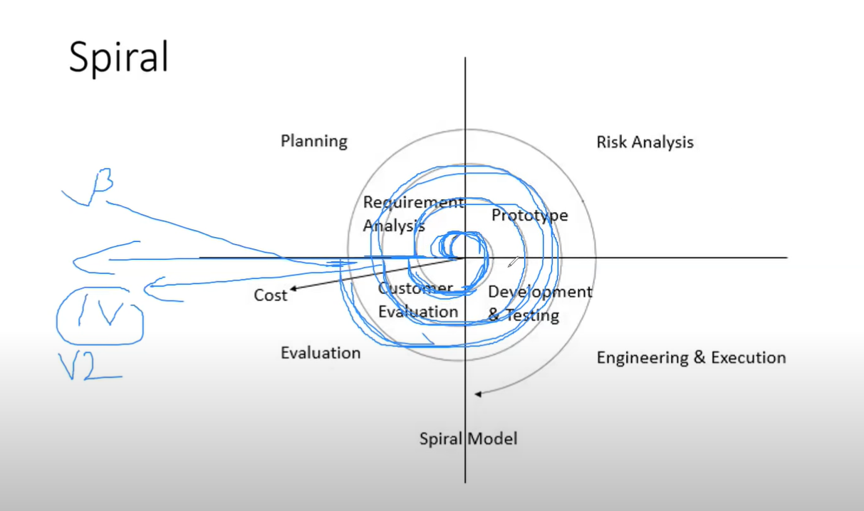

Spiral Model

27

28 Spiral Model is iterative model.

29 Spiral Model overcome drawbacks of Waterfall model.

30 We follow spiral model whenever there is dependency on the modules. 31 In every cycle new software will be released to customer.

32 Software will be released in multiple versions. So it is also called version control model.

Advantages of Spiral Model

1. Testing is done in every cycle, before going to the next cycle.

3.Customer will get to use the software for every module.

4. Requirement changes are allowed after every cycle before going to the next cycle.

Disadvantages of Spiral Model

1.Requirement changes are NOT allowed in between the cycle.

2.Every cycle of spiral model looks like waterfall model.

3.There is no testing in requirement & design phase.

**Prototype:blueprint of software**

Initial requirement from customer->Prototype->Customer->design,coding,,testing

**V-Model**

In every step we do testing means in **requirement** stage we do testin,in **design** phase we do testin,**coding** stage we do testing,**testing** phase we testing

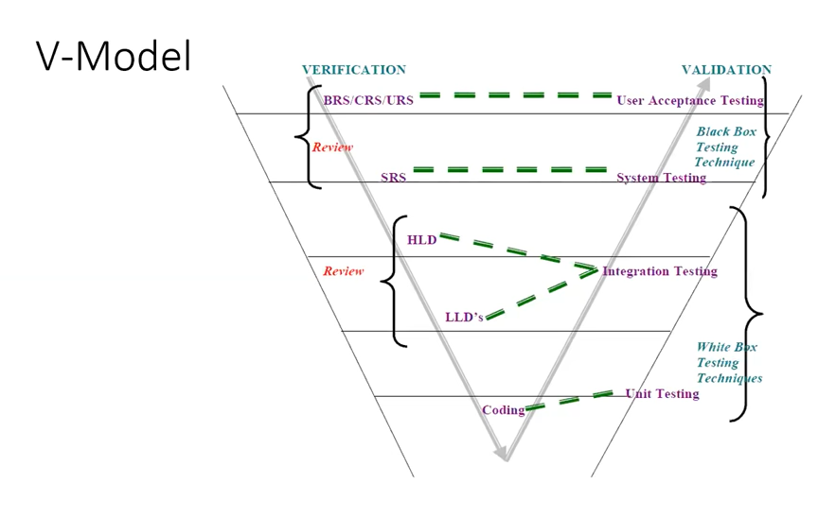

1phase-**BRS/CRS/URS**->Business Requirement Specification/Customer/User.

->Document provided by customer this is prepared by business unit not by technical people.

BRS is input to USER Acceptance testing.UAT will be conduct based on the BRS docu

In this they revew the docu and review the docu is crrct or not this iskind of testing

2 phase->**SRS**->Software Requirement Specification.->Document will be prepared by technical people

3phase->Based on SRS designer prepare HLD(High level Design) and LLD(Low level Design)document.

HLD:High level Design Document ->It contains High Level features of the software,ER diagram

LLD:Low level Design->It contains Low level Features of the s/w.

HLD and LLD is done by designers and then the developers start coding to LLD module.

**Static Testing->**Testing the project related documents is called as static testing.

Static means we testing document is static in form of reviews inspection

4 phase-**Coding->**they do **unit testing** and **even integration testing i**s done by developers

**5 phase->Unit testing**

**6 phase**->Integration testing

**White Box testing->**Whatever testing we conduct on code is white box testing techqines

7 phase **System testing->** Tester->Then testers do **system testing** ->they just functional and all.

Blackbox testing->we don’t knw what developers written internally is black box

8 phase **User Acceptance testing**->This is done by testers and customers and it comes under black box

Dynamic testing->Actually testing the software not document

Unit testing,integration,System testing,UAT->Techniues

**QA vs QC**

QA-it is process related,

1)QA they see process is following are not ,they ensure process is done,high level management people are done.

Its is process related

QC-it is a software testing.

They involved oly comes under testing.

They test the software

**QA focuses on building quality**

**QC focuses on testing quality**

**QA is for preventing the detect**

**QC is detecting the defect**

**QA is process oriented**

**QC is product oriented**

**QA is for entire life cycle(SDLC)**

**QC is for testing part of cycle**

**QE**-Quality engineering:in this they write code but testing the software(Automation testers)

**SDLC**

Requirement analysis

Design

Development

Testing

Deployment

maintance

**Level of software testing**

Unit testing-some component tested by coders

Integration testing-multiple modules combining into single and testing the flow of data with each module

System testing-testing overall software according to customer needs

User Acceptance Testing(UAT)-testers and users testing

**Unit Testing-**

1)Unit testing is a single component and module.

2)Unit testing is a white box testing

3)unit testing is done by developers

4)Unit testing is conducted by single programs.

4)Unit testing techniques:

i)Basis Path testing-testing each path of code line once

ii)Control structure testing-

-Conditional coverage

-Loop coverage

-Mutation coverage

**Integration testing-**

Integration testing is testing between 2 or multiple modules.

Integration testing is checking data communication between multiple modules.(giving input to one module and producing output and that output will be input to other module )

Integration testing is white box testing techqi

Testers can also do integration testing

Types of integration testing:-

1)Incremental integration testing:-incrementing(adding)modules and testing the data communication

Top down approach Incremental integration testing-Incrementing the modules and testing the data flow of the modules and ensure that the module added is child of previous module(parent)

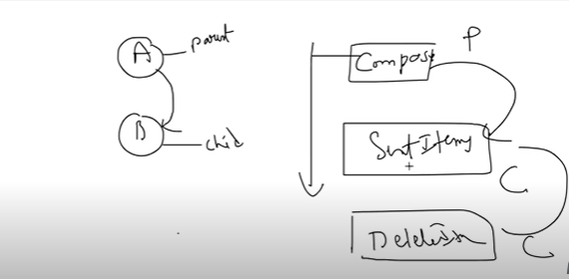

Fig: Top down approach

Bottom up approach Incremental integration testing-Incrementing the modules and testing the data flow of the modules.and ensure that the module added is parent of previous module

2)Non-incremental integration testing: Adding one single shot and testing the data flow between the modules

Draw backs:

We might miss the module during testing

**System testing:**

1)Testing the overall functionality according to client requirement

2)System testing is black box tech

3)It comes after unit and integration testing

4)It is conducted by testing team

**5)System testing focuses on**

**i)User Interface testing(GUI)-ui of the application, testing ui part testing the textboxes .look and feel of the application etc**

**ii)Functional testing-test the functionality (ex: bank example( login is one functionality, balance functionality, adding pay functionality).**

**iii)Non-functional testing-non-fuctionality means (once functionality is good then we do non,non-fuctionlity means performance testing)**

**iv)Usability testing-**

**User Acceptance testing**

After system testing we do acceptance testing (UAT),uat team does acceptance testing in two ways

1)Alpa testing

2)Beta testing

System testing

1)GUI –What is GUI Testing?

Graphical User Interface testing or GUI testing is process of testing user interface of an application.

A graphical user interface includes all the elements such as menus,checkbox,buttons,colors.

It focuses on frontend.

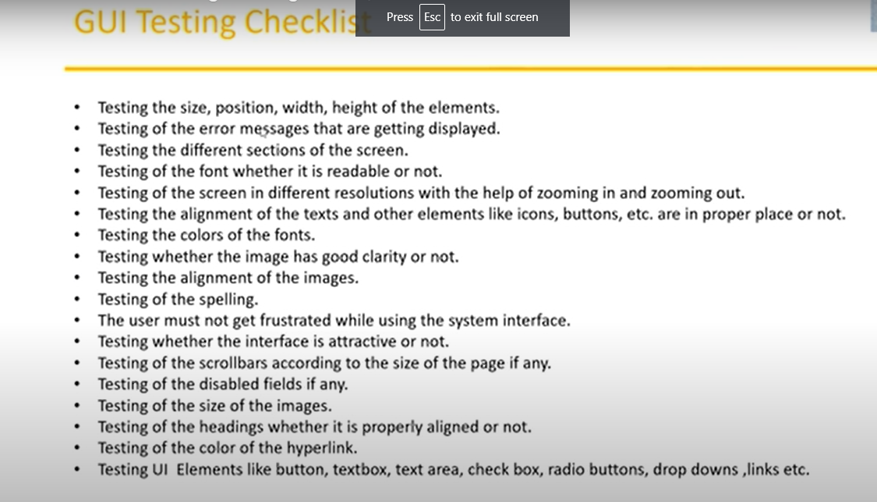

2)Usability Testing-

Easiness of the application.

Checks how easily the end users are able to understand and operate the application is called usability testing.

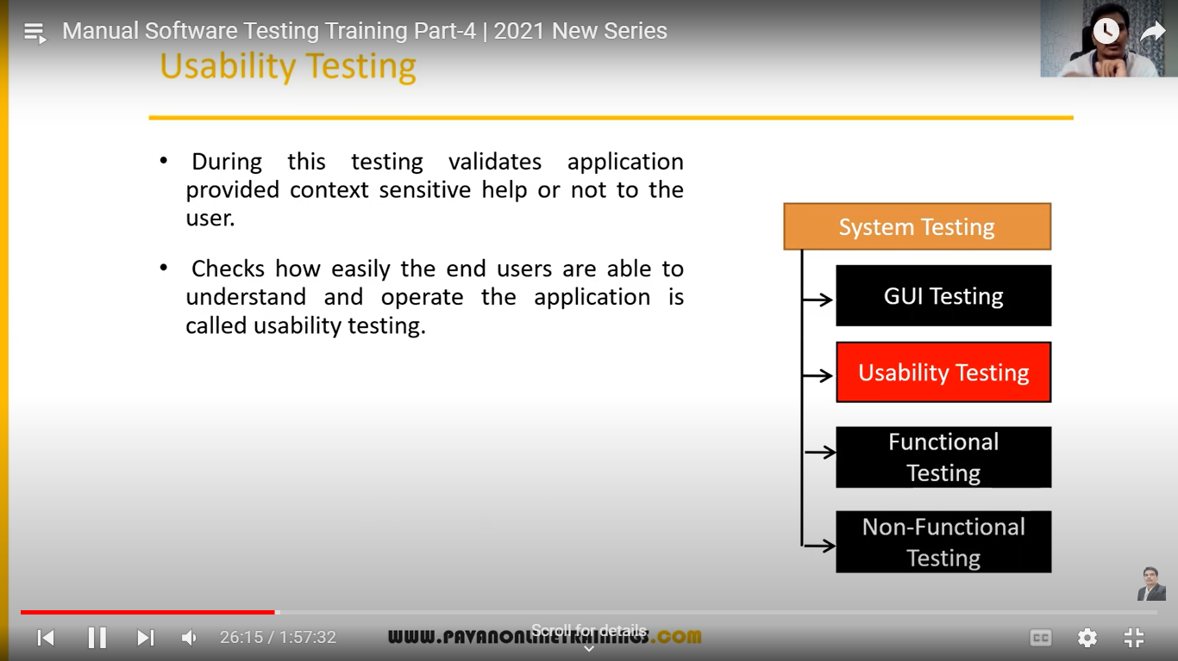

3)Functional Testing

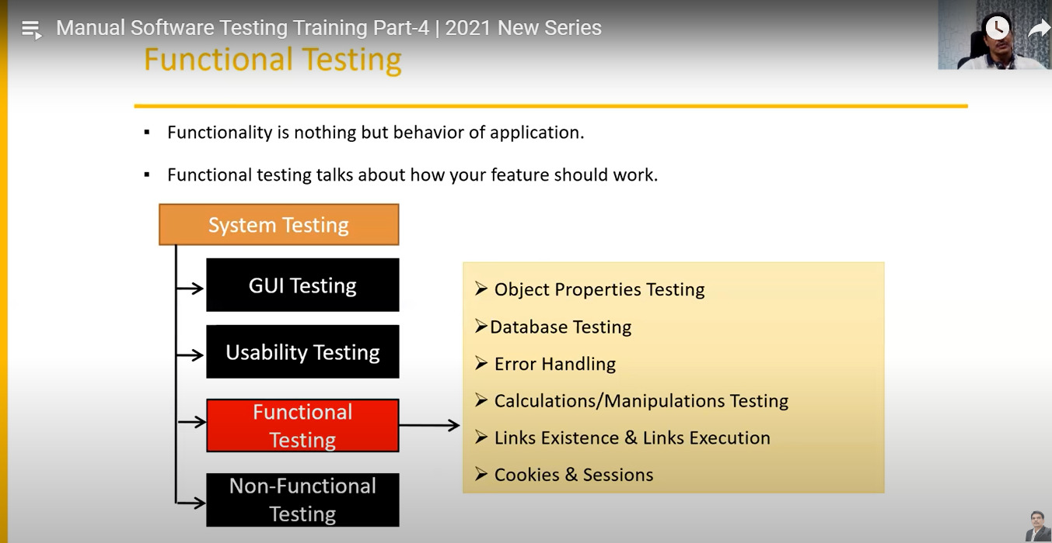

i)Object properties testing:- ex:in uI thr will be radio button like female and male in this oly one radio button should be clicked so here male and female is a properties

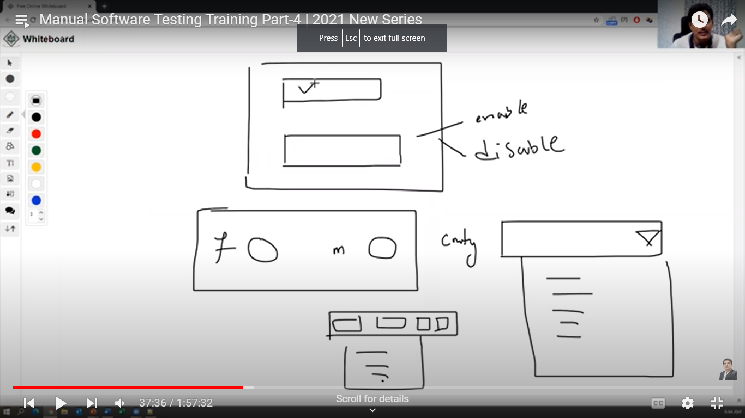

Object properties: Check the properties of objects present on the applications.

Ex: Enable, disable,visible ,focus..............

**2)Database testing**:focusing on bank end

It is als a backend testing .

DML Operations(Data Manipulation Language**):Delete,update ,Insert,Select**

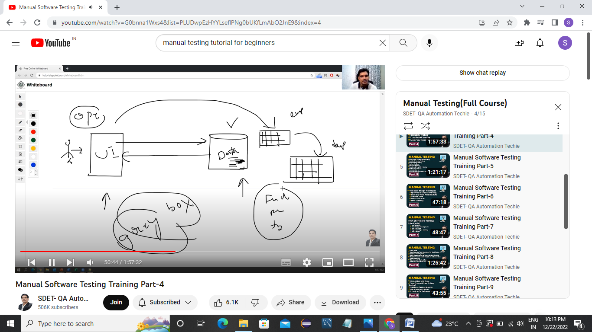

Whatever we submit the data in Ui it will send to database and data will send to user.As user we don’t see the

It contains Black box and white box testing.functionsl and non functional.

As functional tester we perform some like inserting the data,deleting,updating the **delete,selecting the data.**

Data will store in form of table in database

So whatever operations we perform in UI ,it gets affected in database table

How database testing works.

First we submit the data in UI

Then we login to Database,we see in database table it is **updated,inserted ,or**

We see Communication between UI and database is working fine or not.

From UI we are doing **blackbox testing**(becuz we don’t know coding here)

In database we are Loging in and we are writing some queries hereto check data in table it is **white box testing.**

In this we do both **Black box** and **white box** so combining it we get **Grey** **Box testing**

**Yes there is a Grey box testing, example is database testing**

**3)Error Handling:-Testers verify the error messages while performing incorrect actions on application**

**i)Errors message should be simple or in simple language**

**4)Calcualtion/Manipulation testing:Calculation is correct or not,we need to test valid and invalid als**

**5)Links existence and links execution:We are checking link is working or not**

**Three types of execution:**

**1)Internal links-means when we click on link it should open same page in different tab**

**2)External links-means when we click on link it should navigate to next page**

**3)Brokens links-means it does not go to any next page**

**6)Cookies and Sessions:**

**Cookies are related to the browser**

Cookies are the: Temporaray files created while browsing the internet page.

Ex:when we login to gmail and just close like that only and again if we open gmail the page opens directly...this becuz your browser remembered the cookies information.

**Session will be created at server side**

Ex: when we login to anything.....and don’t perform anything for a while then it shows **session timed out.**

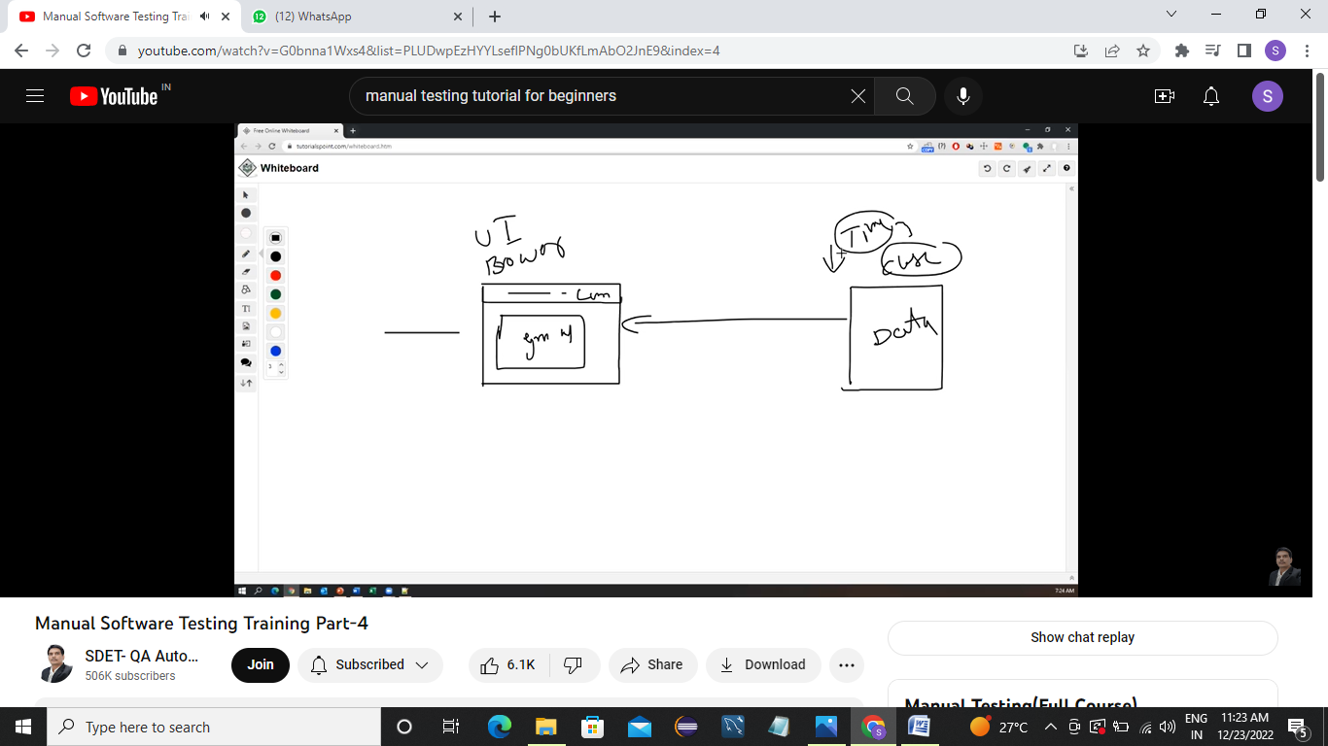

**Session are time slots created by the server .Session will be expired after sometime If you are idle for some time.**

**Non Functional testing**

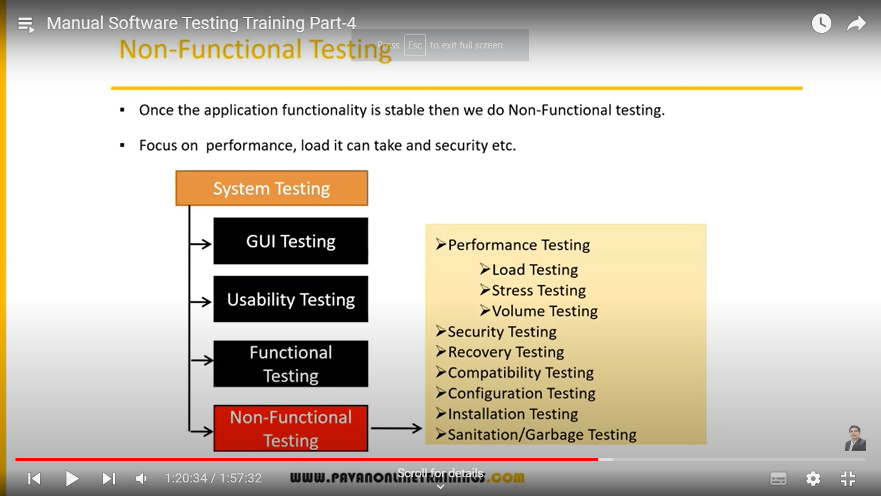

**Focuses on customer expectations**

**Nonfunctional testing is not easy it requires special testing environment people .**

**Performance Testing: means speed of the application. It is done for web applications**

**It contains:**

**Load testing:**

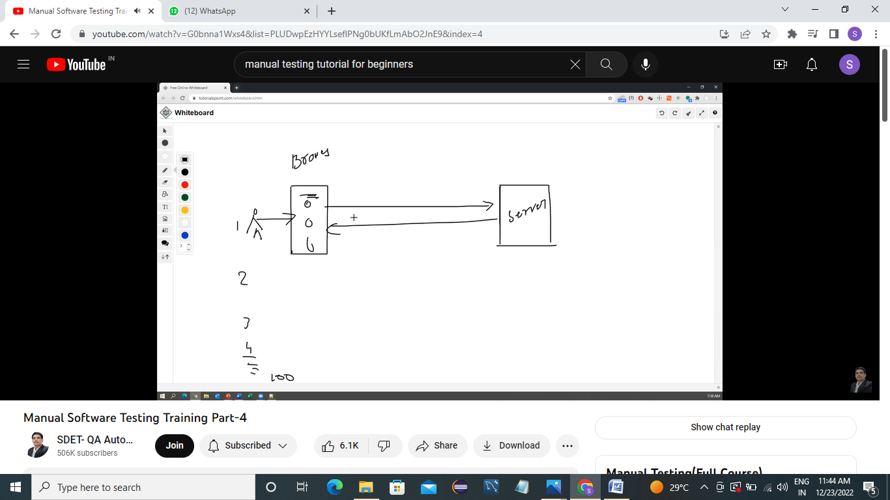

**Gradually Increasing the load on the application slowly then check the speed of the application.**

**Stress testing:-Suddenly increase or decrease the load of the application**

**Ex: amazon, flipkart announce offers number of people will acces the application same time that server goes done.**

**Volume testing:Verify,check How much data our application is going to handle.**

**Security:ex:banking and finance**

**Verifying how secured our application is going to test.**

**This is done by specialist not by nomrmal testers .**

**It conatins:**

**Authentication-checking Users are valid or not**

**Autherization/Access User-if user is valid :**

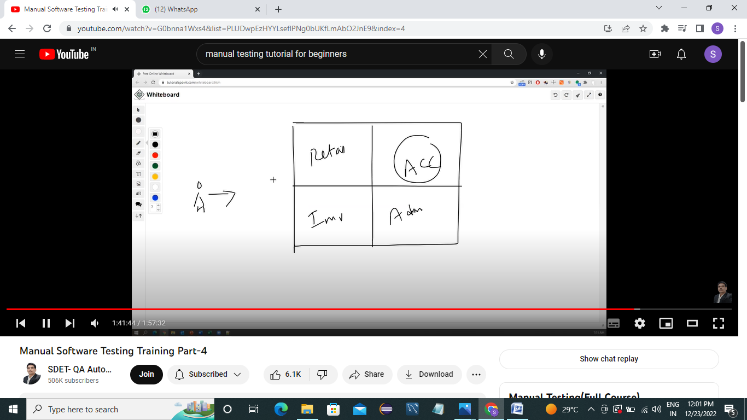

**Permissions of valid users,and what are the features he can access**

**Recovery testing: If i lost something i need to get back.Means if we delete and we want data it should get back. If our application has recovery testing and all.**

**Example:In mail we will be having draft session the composed mail will be in draft session..that is recovery mechanism.**

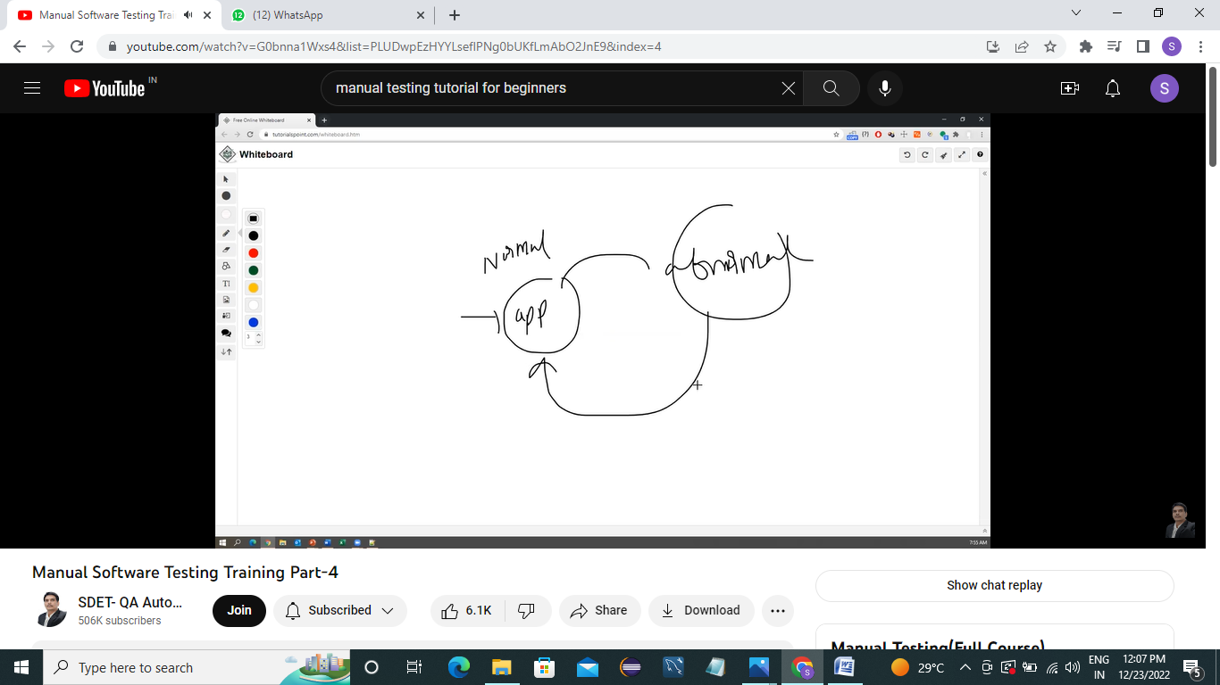

**Checking the system is abnormal to normal**

**Compartibility testing:**

**1)Forward compatibility**

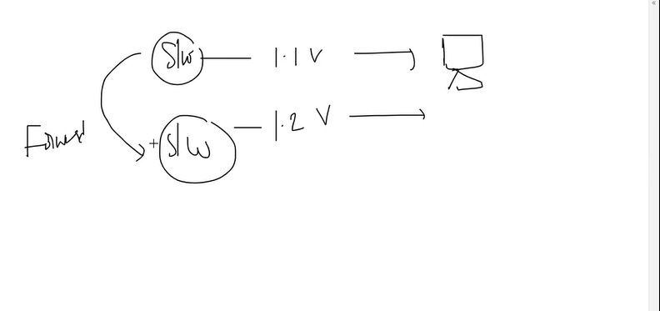

**Forward and Backward means whatever the version is thr it should upgraded with new and it should work properly**

**3)Backward compatibility:**

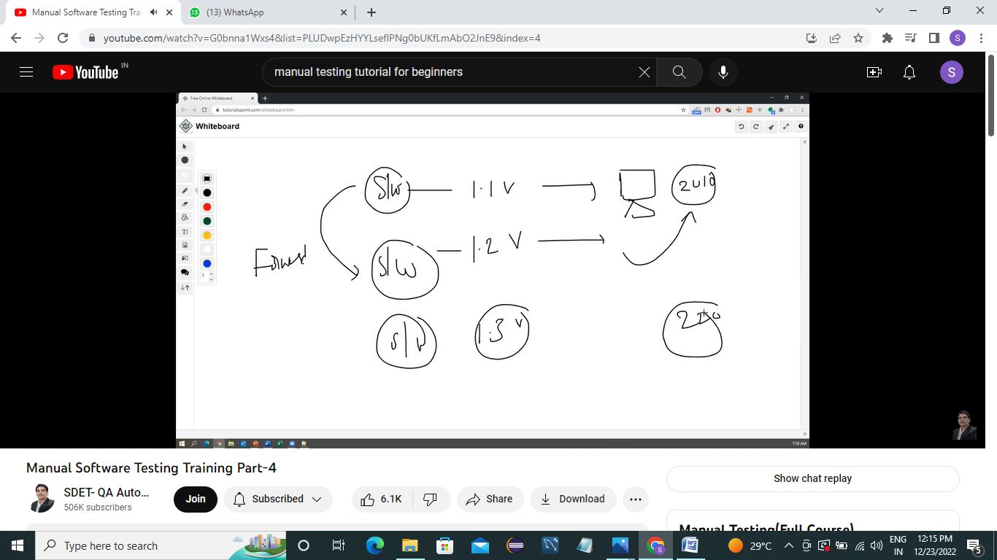

**2)Hardware Compatibilty(als configuring testing):Like customers sos so ram size tell some configuration and it should work on tht environment ,it should see it supports linux,or not unix or not,working with 4 gb or not.2 mb harddiskm or not.**

**Installation testing:**check screens are clear to understand.Testing installing

Simple or not.Uninstall s/w

**Garbage testing/sanitation**:Remove unwanted stuff from the software.

If any application provides extra features/functionality then we consider them as bug.

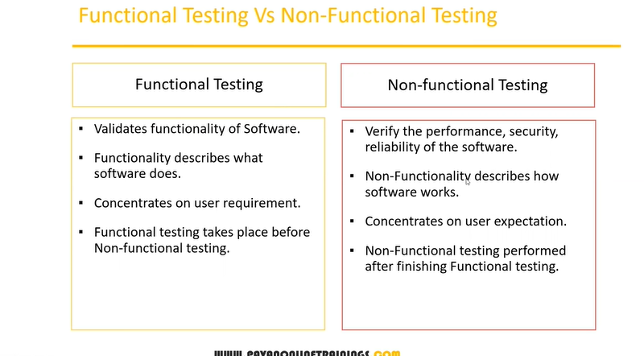

**Regression Testing:-**

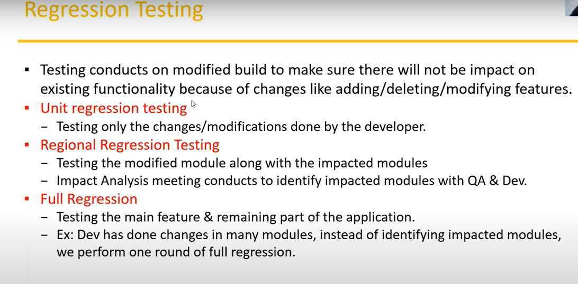

**Unit regression testing :Testing specific module.**

**Regional regression testing:**

**Retesting:-**

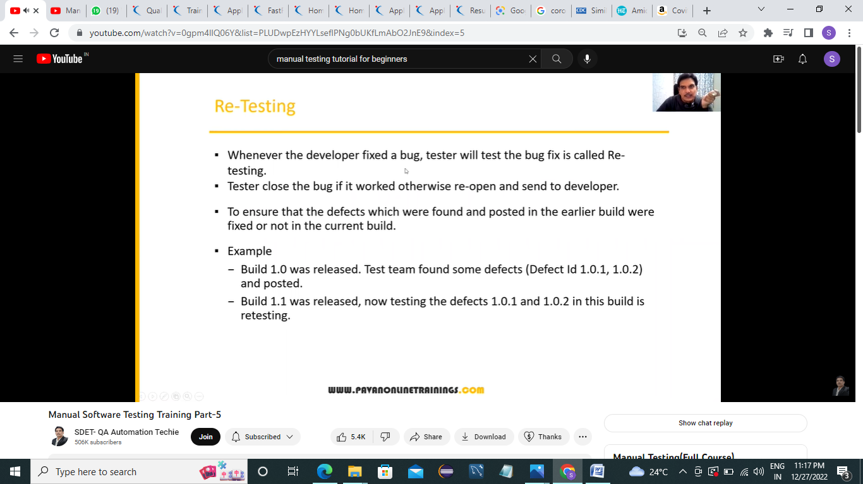

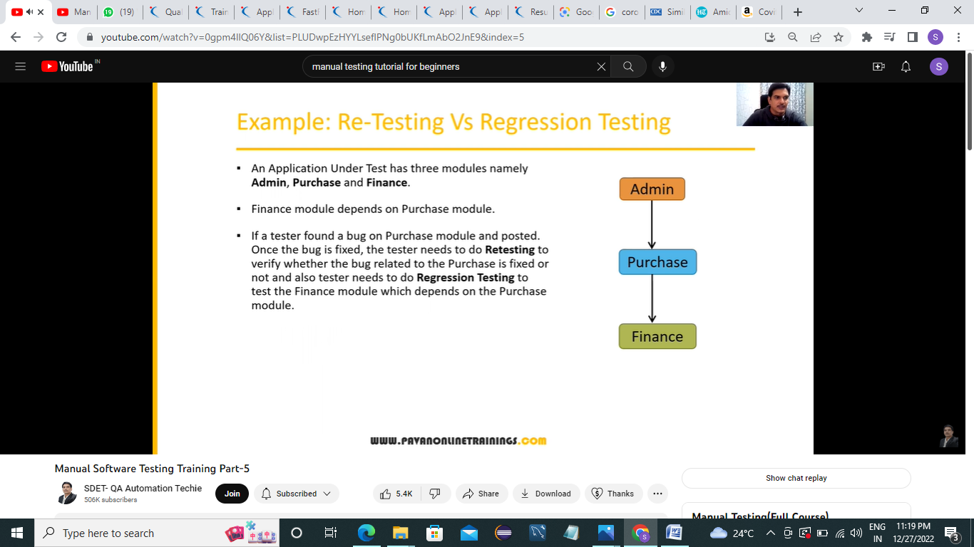

**Smoke testing:**Build is stable on our environment or not.,proper installation,checking link is working or not,navigation is working or not(like home link is working or not).

Whenever dev provide build(a s/w) to a Tester,as a tester we don’t do deep testing,we do basic testing.As soon as we get s/w we check we got cmplt build or not,thn we do installation part,check whether installation is crrct or not.

Frequently testing smoke testing.stability of build

**Sanity Testing:**it als is regression testing but focuses on functionalities like login is working or not

**If both got failed then we reject the build then prepares another build.**

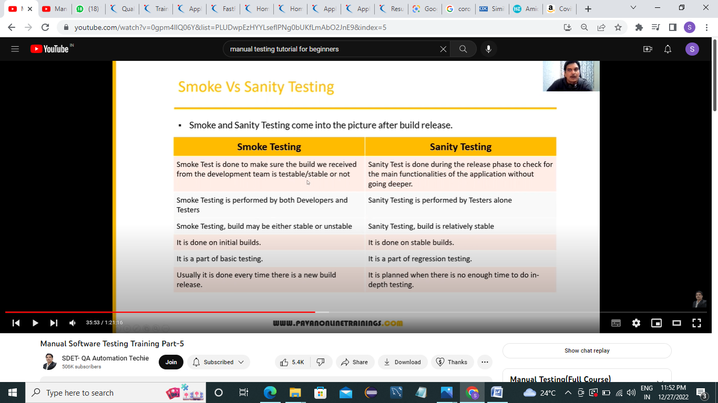

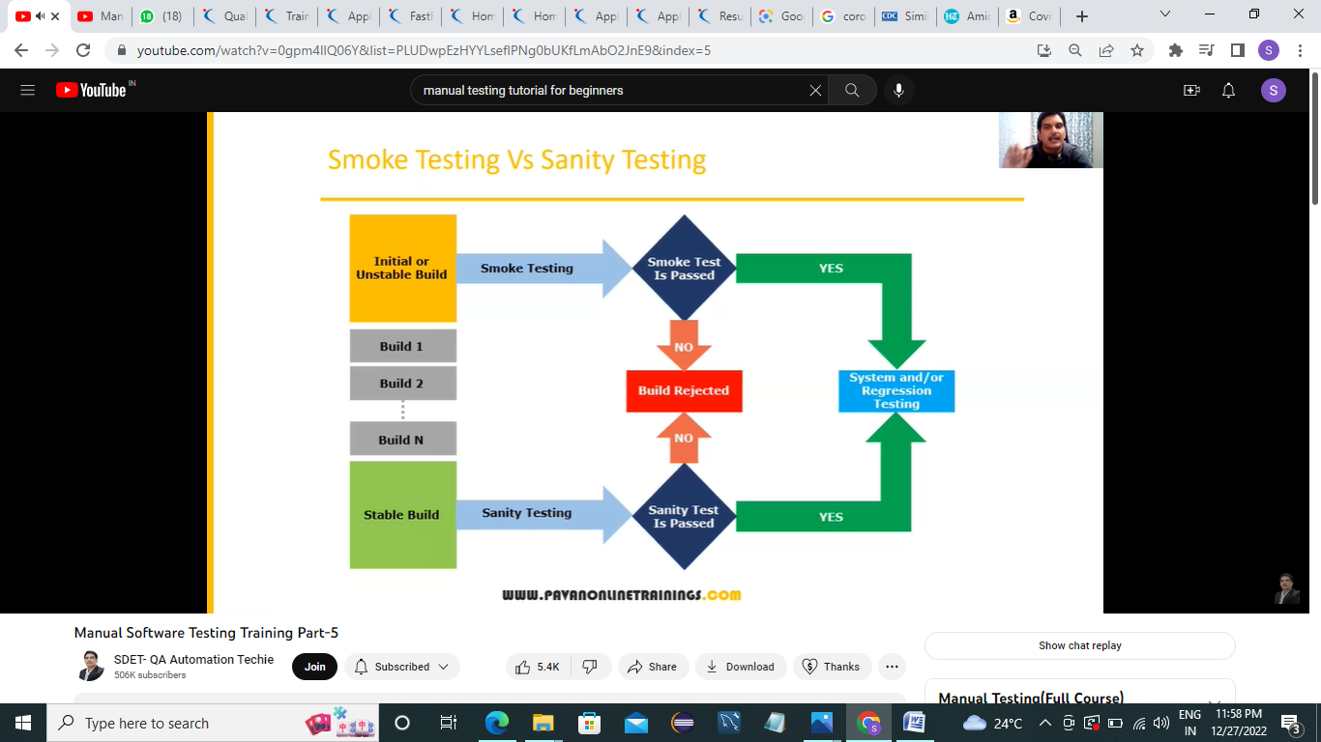

**Explorating testing:**

**Explorating is done when application is read but document is not thr we do explorating testing**

We don’t have any documents,requirements,we only need to understand the functionality by ourselves and test is exploraity testing.

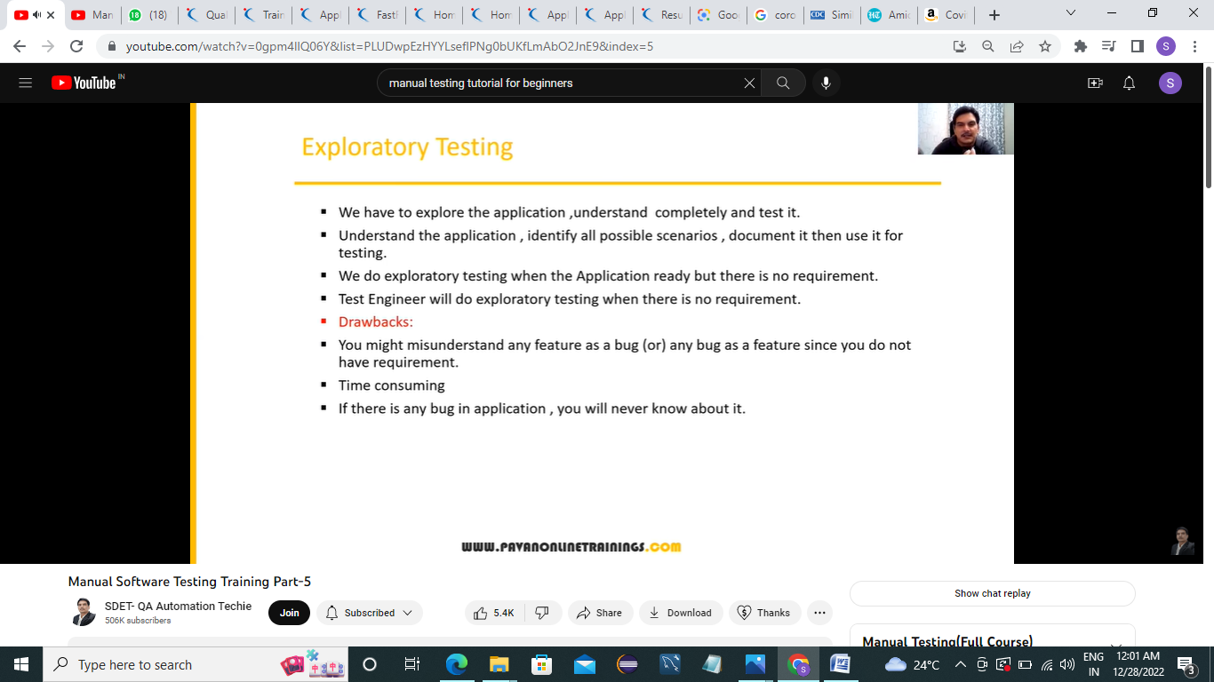

**Adhoc testing(random testing):we will be knowing requirements on the previous experience**

Adhoc is to break the application. It is informal 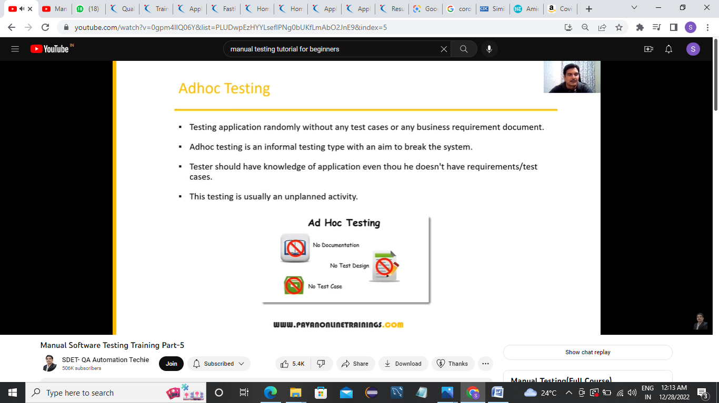testing.

**Monkey/Gorilla testing**(testing randomly but without knowledge of requirement or functionality ,but still we can test ):

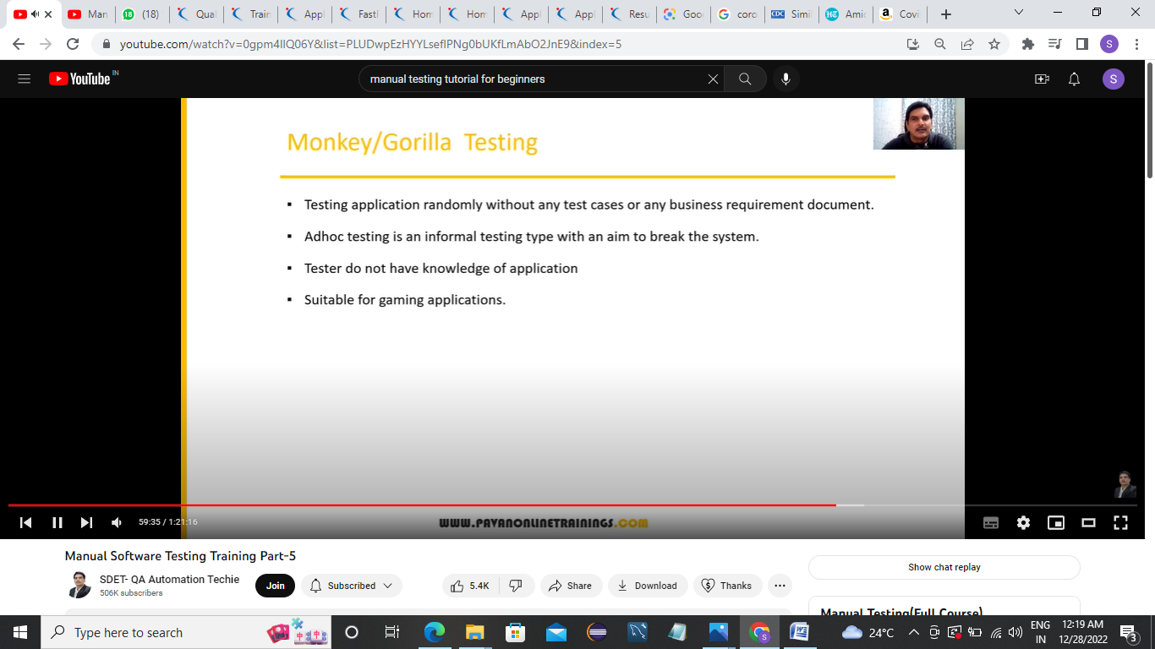

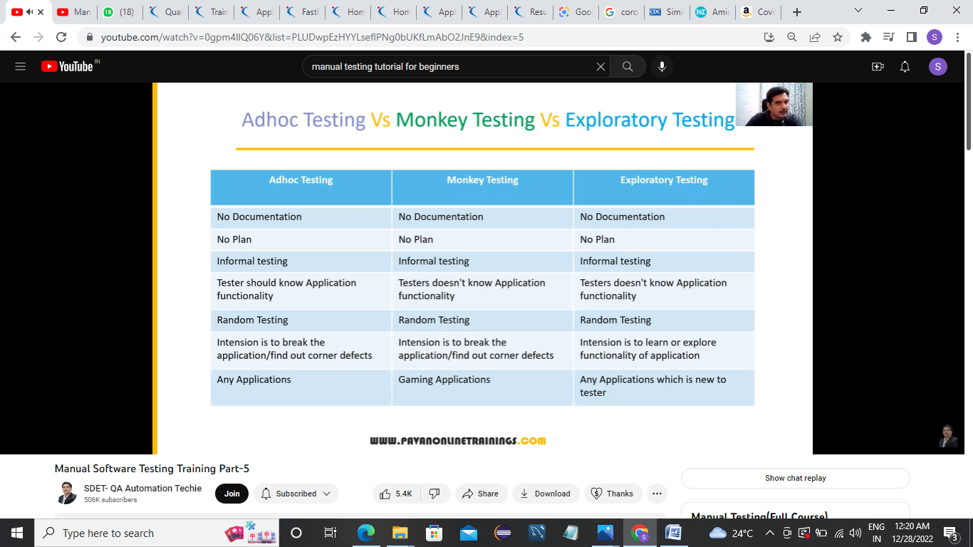

Positive testing: Testing application with valid inputs is positive testing

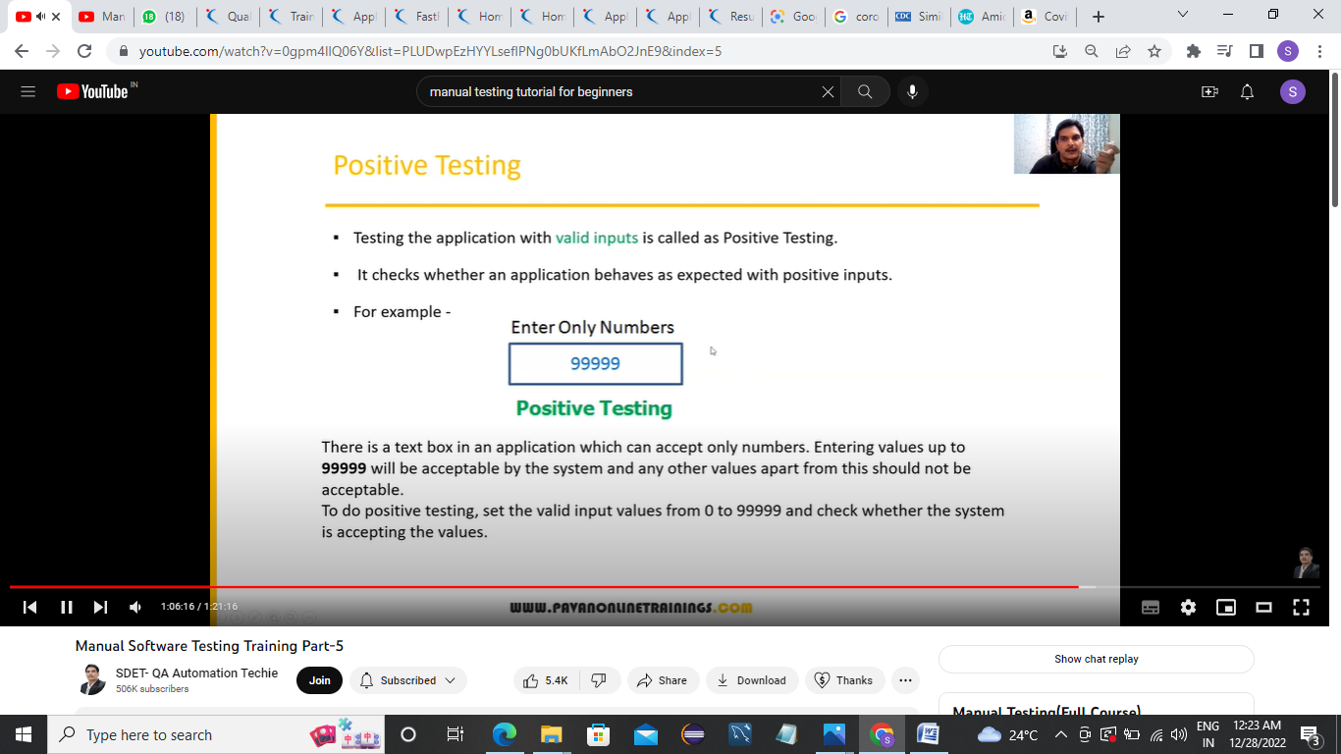

Negative testing:Testing application with invalid inputs is -ve

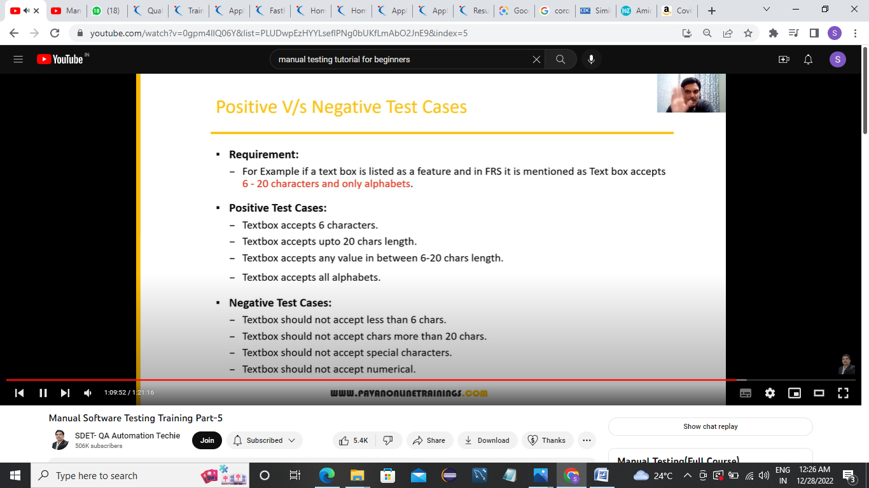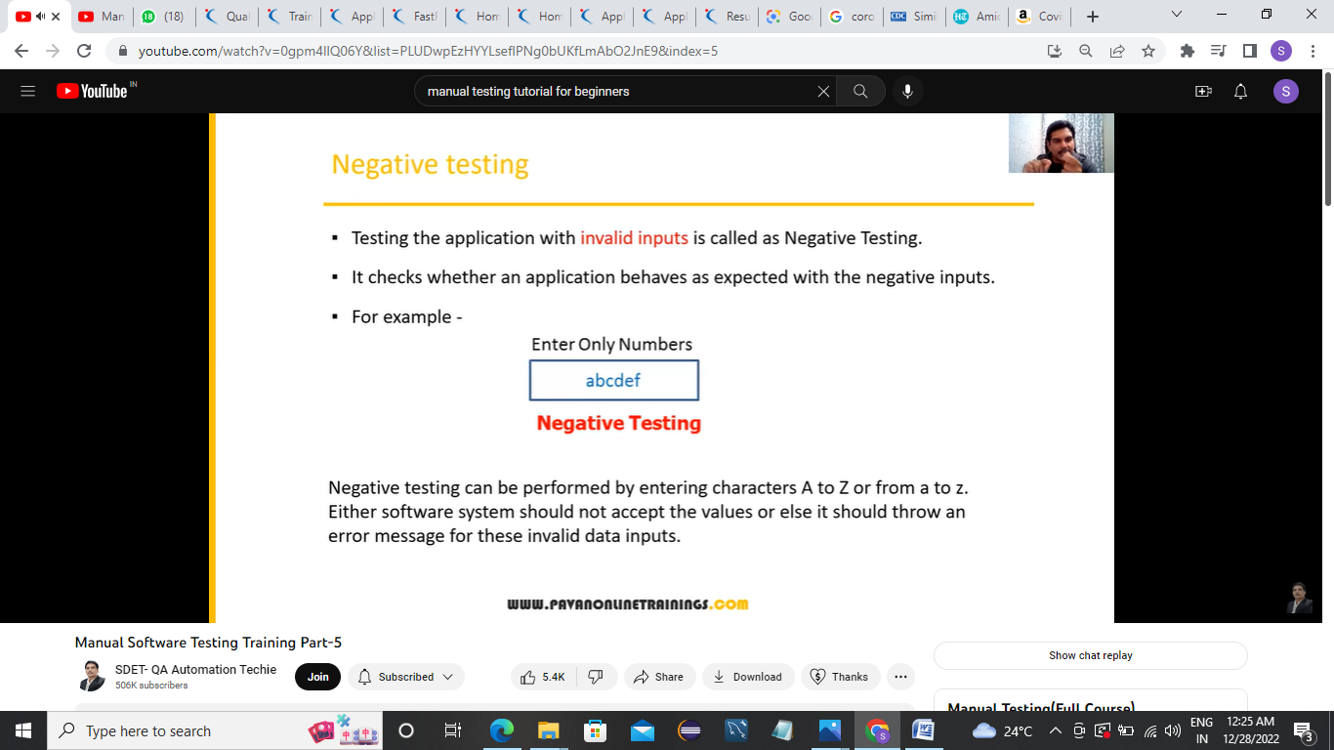

END-to-END testing:Testing overall application where application covers all features

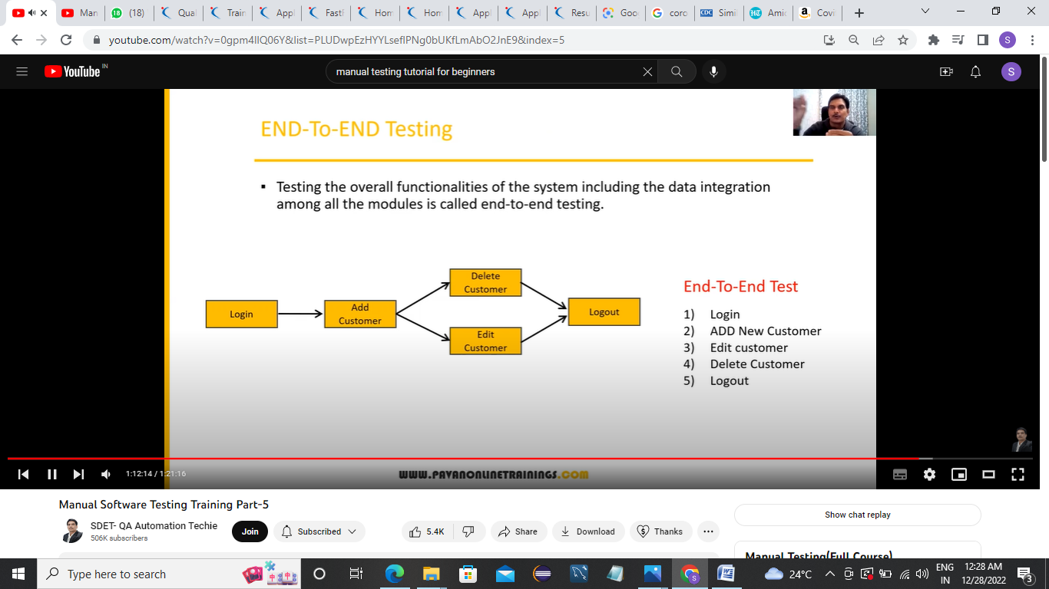  
it should cover every flow

Globalization(I18N) and Localization testing:

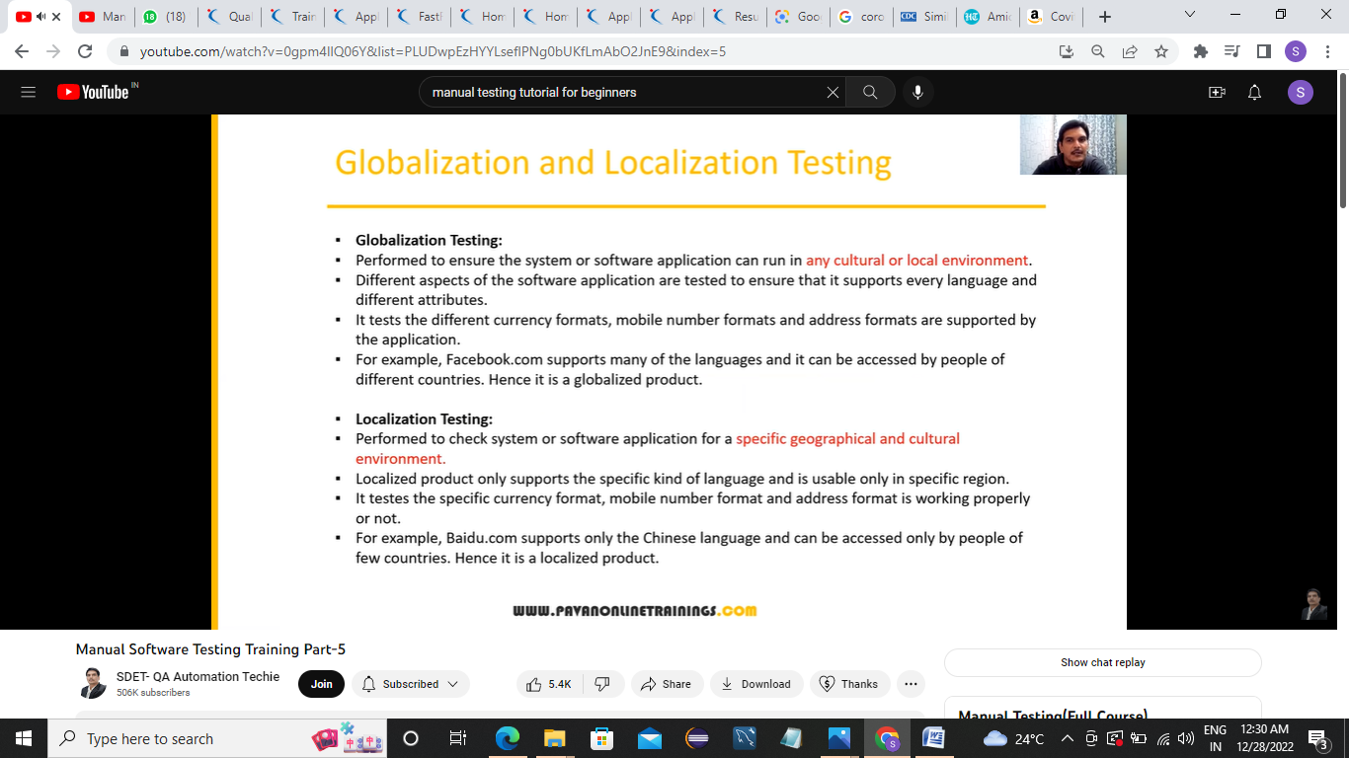

Global:ex :facebook where it can be used by all language people

Local:only for particular languages like Chinese

Test design Techniques:Used to prepare data for testing

1)Data:reduce data

2)Coverage:More coverage

Five types of techniques:

1)Equivalence Class Partioning(ECP)

2)Boundary Value Analysis

3)Decision Table based testing

4)State Transition

5)Error Guessing

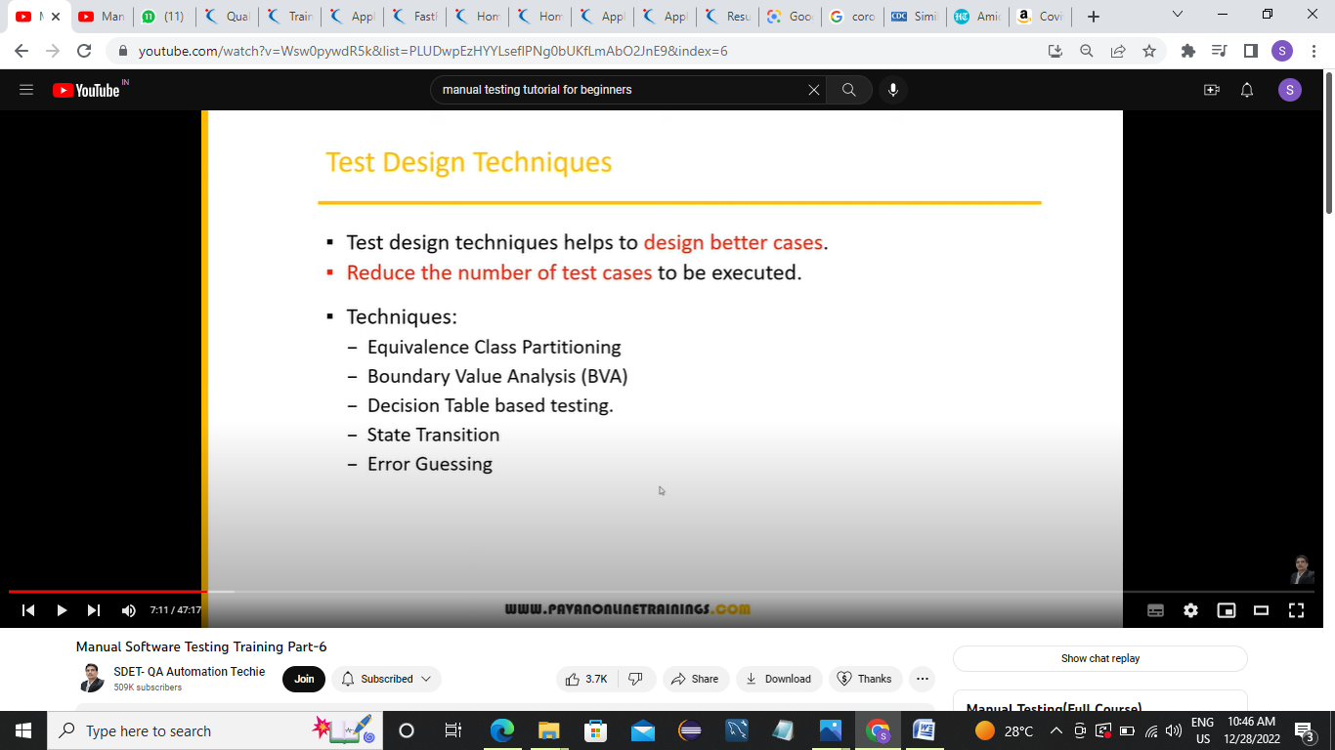

**1)ECP:-**

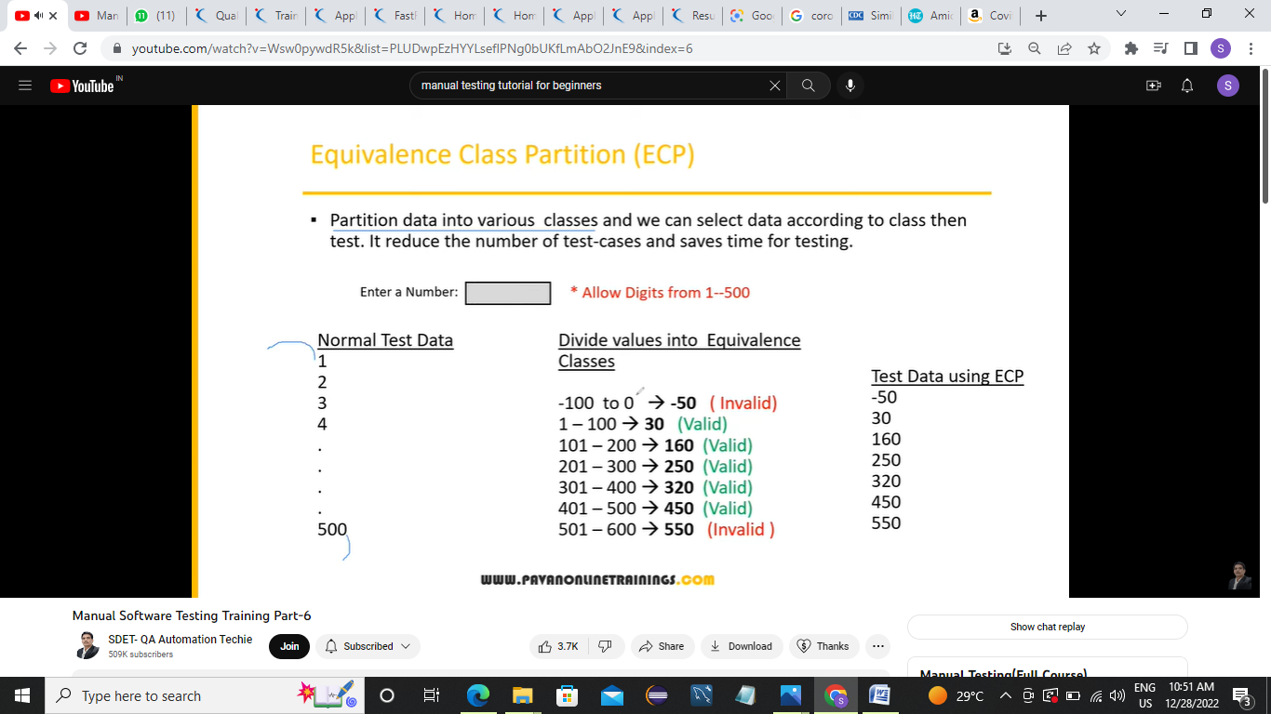

Value check

Dividing data into multiple classes

Boundary Value Analysis(BVA):

We focus on boundary value

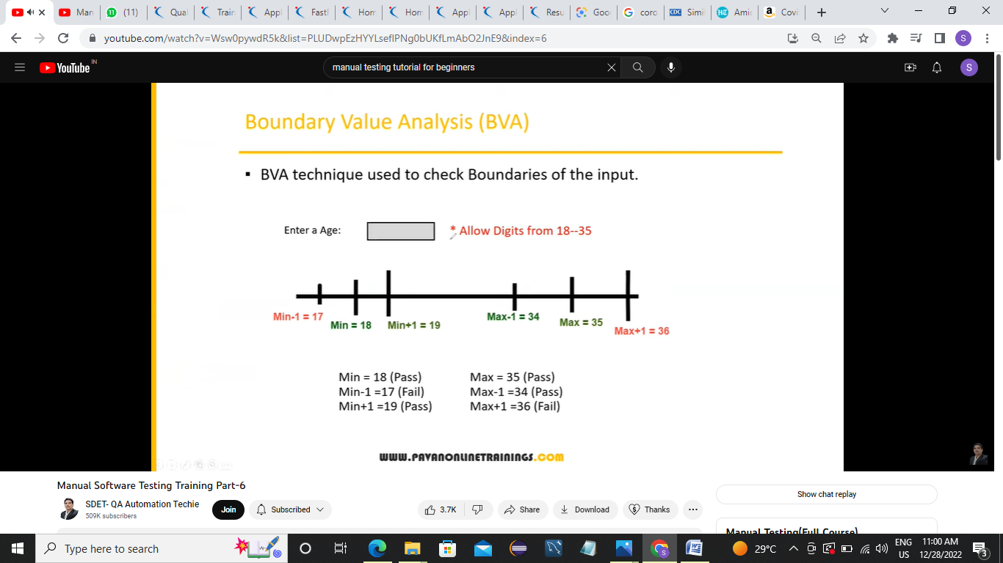

We check oly 6 parameters:Min,Min-1,Min+1

Max,Max-1,Max+1

*ECP and BVA tecqniues we use for **input domain testing.**

**Input domain testing:**The value will be verified in the text box/input field.

We use ECP and BVP tecqnices

**Design Table Tecq:**

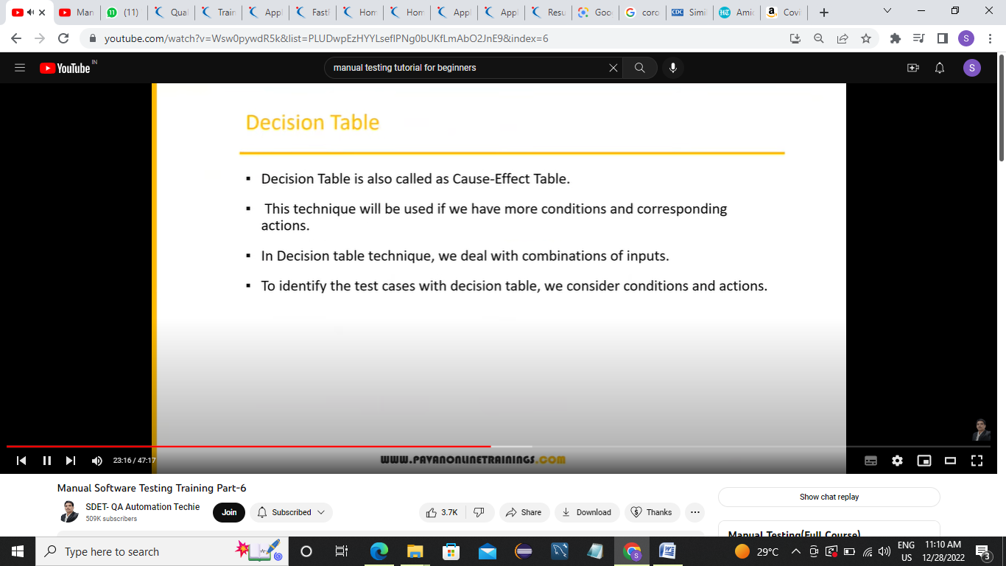

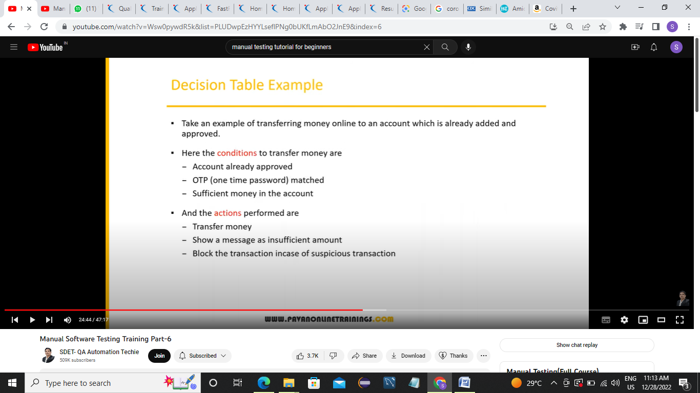

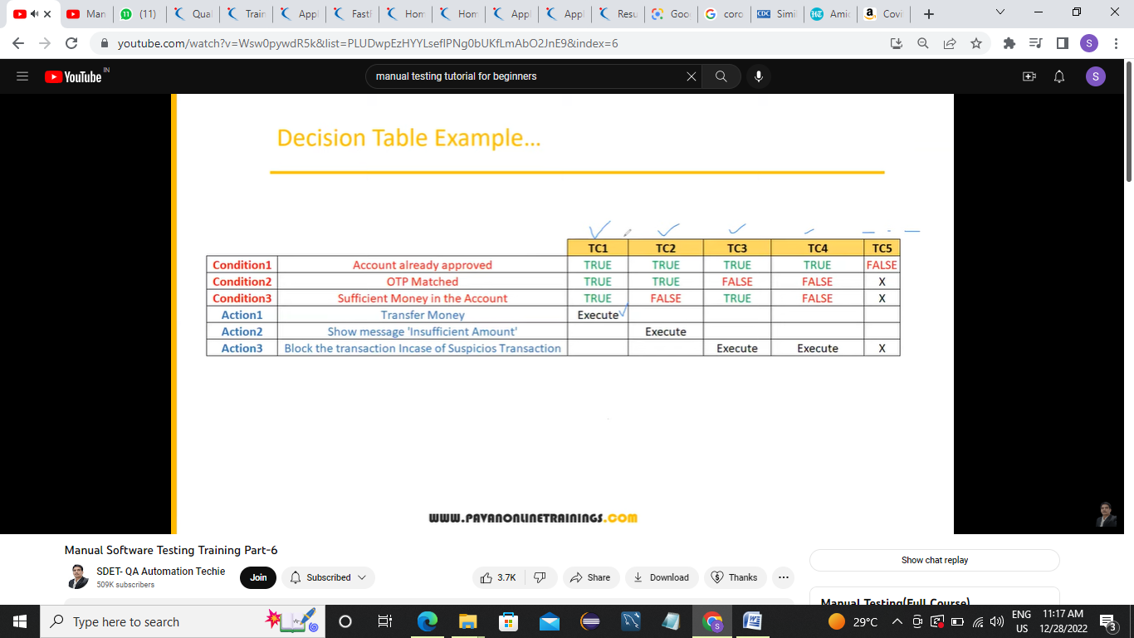

1)vALId

2,3,4)negative

5)Invalid

If we have ,more number of conditions,then we use decision Table

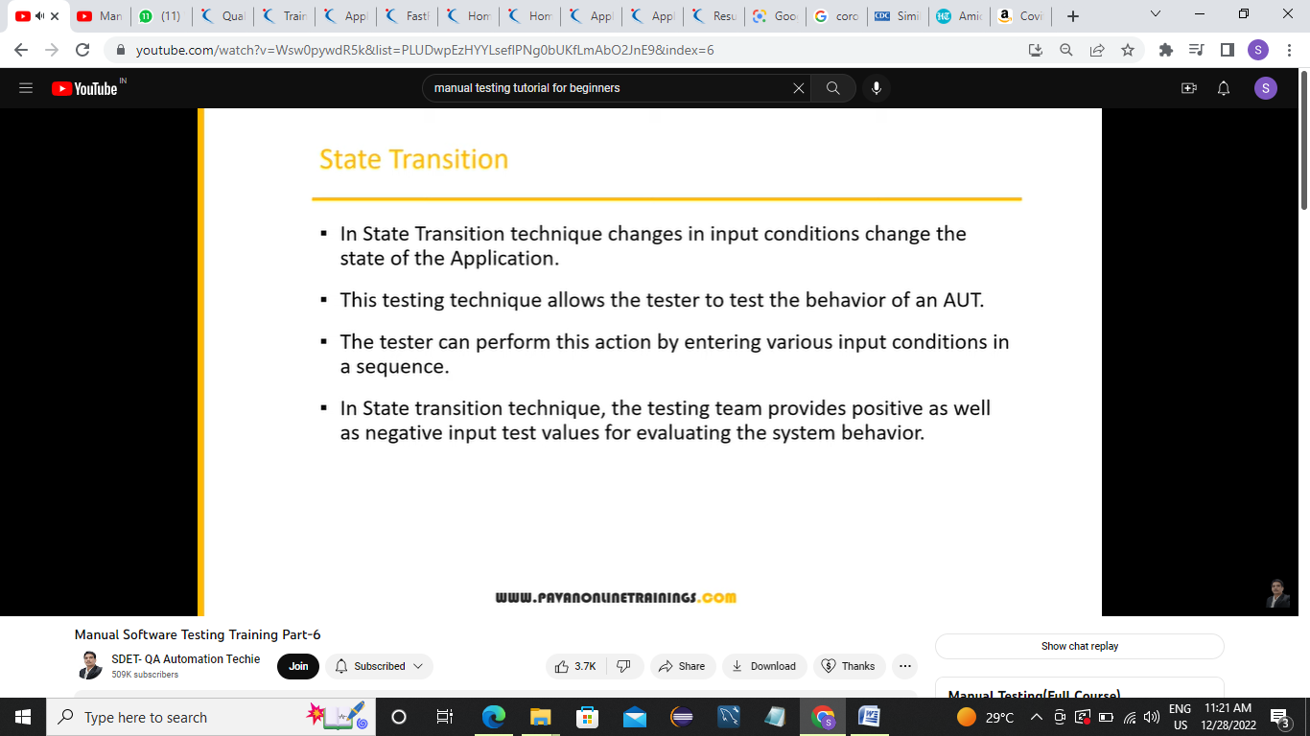

Ex:

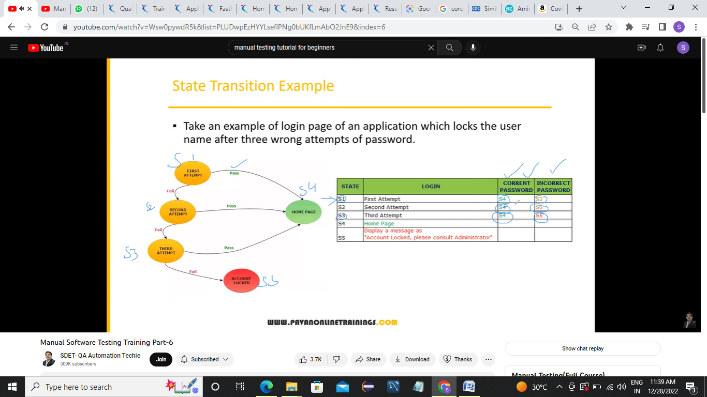

State tecq:will be used we have multiple states,we focus on states

**Error Guessing technique:**

**We don’t need any documents and all**

**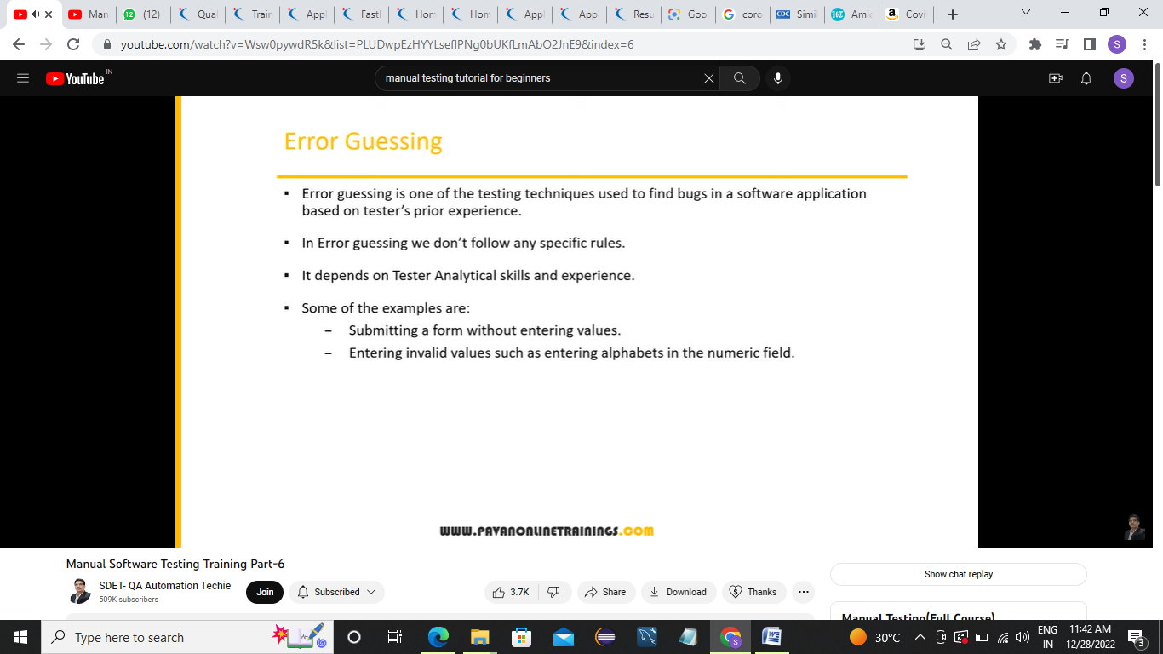  
  
ec:while adding to addcart ,if the product is not adding to a cart then it is a error**

**SDLC:**

**It contains Req analysis,Design,coding,testing,deployment,maintance**

**STLC:Software Testing Life Cycle**

**It contains:**

**1)Requirement Analysis**

**2)Test Planning**

**3)Test Designing**

**4)Test Execution**

**5)Defect reporting/Bug reporting and Tracking**

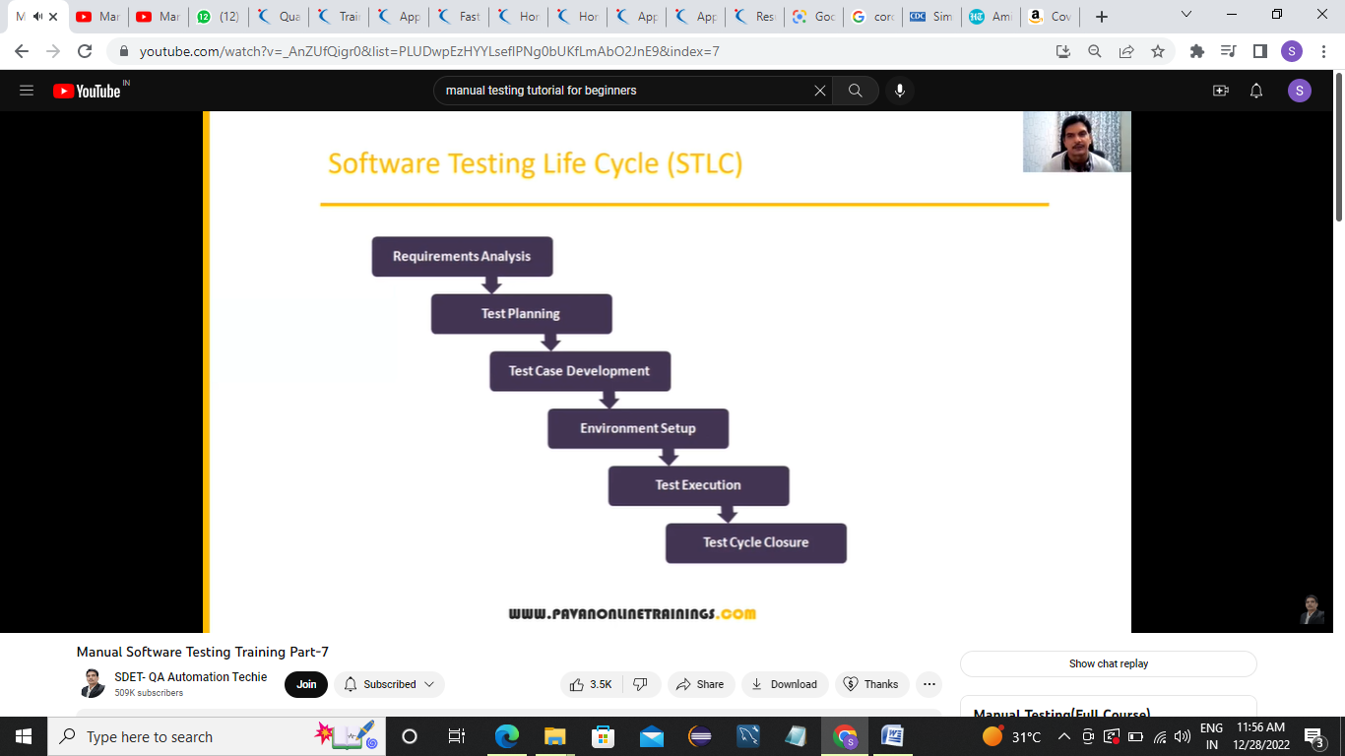**6)Test Closure**

**Requirement:We understand the functionality**

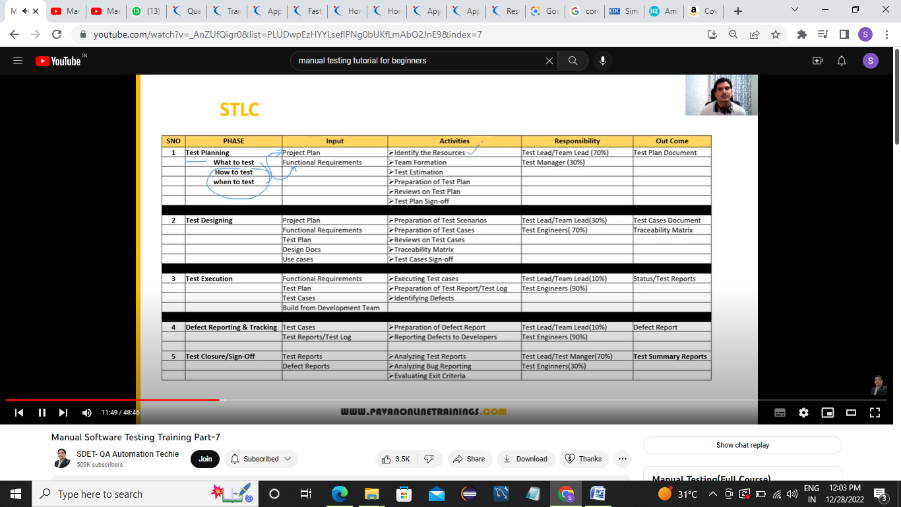

**Resources means:s/w,hardware**

**1)Test planning**

**Team:who will do manual testing.automation testing,**

**Test Estimation:Estimating how much months,time duration,how much we have to spend for testing phase.**

**Test plan:contains plan,what to test,what test we have to do and all**

**Review test plan:Reviewed by the team along with project management.when we get approval or sign off**

**Signoff:thy write email we are approve,then u can proceed**

**2)Test Designing/development:**

**Project plan,Functional require,Test plan,**

**Design docs:Sometime we requi design docu.which contains buttos,then to know ui level requirement we refer design docs**

**Use cases(requirement):it is part of require,it helps us to undertstand requi clearly**

**It contains diagrams**

**Activities:**

**1)Test scenarios:Scenario means what to test in application,ex:login box**

**2)Test cases:identifying scenarios,we need to prepare test cases,step by step action.**

**3)Review test cases:we need review test cases again.We do review meeting on test cases.It is mandatory becuz we may miss the scenarios.**

**4)Tracebility Matrix:Mapping between requirement and test cases document we prepare,**

**For ex requ 1 how many test cases are thr**

**5)Test Sign off:everyone should sign off for test cases by dev,customer,thy send email**

**3)Test Execution :**

**1)Functional req:**

**2)Test plan:**

**3)Test cases:**

**4)Build from Development Team:Build means a piece of S/W ,To start exec we need have build**

**Activities:**

**Execute test cases:we do first smoke testing,then sanitary .**

**Preparation of test report/Test log:We prepare doc,**

**3)identifying defects:**

**4)Defect Reporting/Tracking:**

**Test cases,**

**Test log**

**Activities:**

**1)Preparation of Report:we prepare excel sheet and keep tracking**

**2)Reporting defects to developers**

**5)Test closure/Signoff:**

**Test report,**

**Defect report**

**Activites:**

**1)Analyze the Test reports**

**2)Analyzing Bug report**

**3)Evaluating Exit criteria:there will be 2 or 3 p3 bugs,and no p1 bugs**

**Can we produce 100% bug free :no**